Output for Text Extraction:

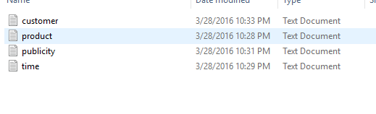

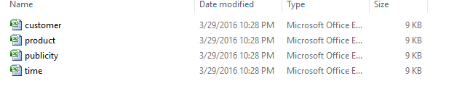

**Before Inserting:**

**Customer Table:**

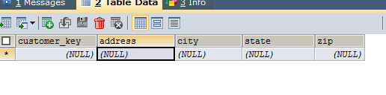

**Product Table:**

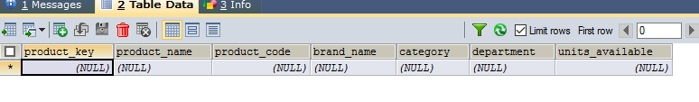

**Time Table:**

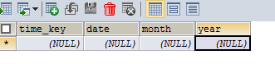

**Publicity Table:**

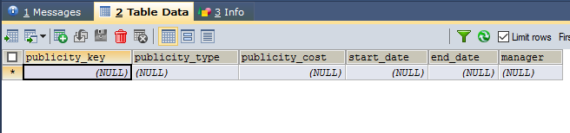

**After extraction, all tables are filled.**

**‘Customer’ Table**

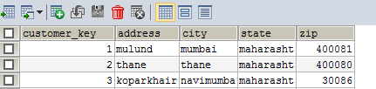

**‘Publicity’ Table**

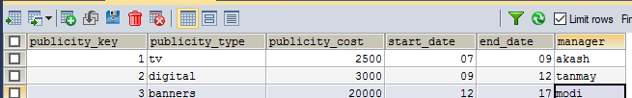

**‘Time’ Table**

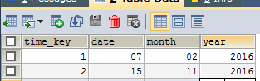

**‘Product’ table**

